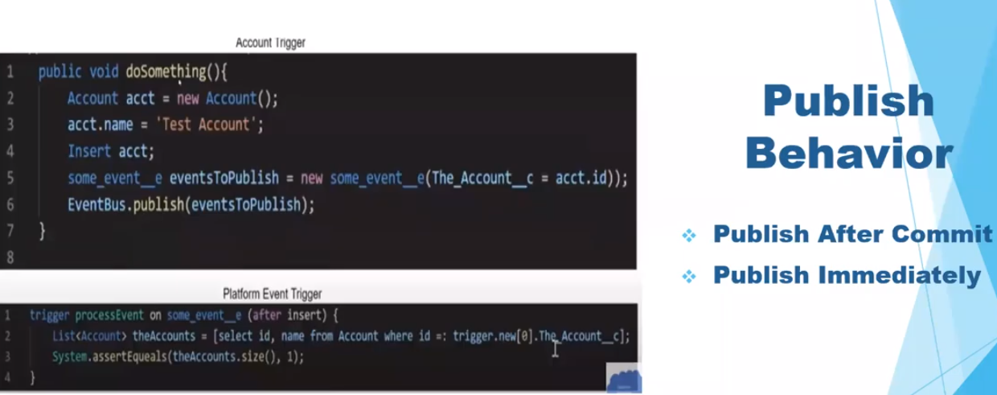

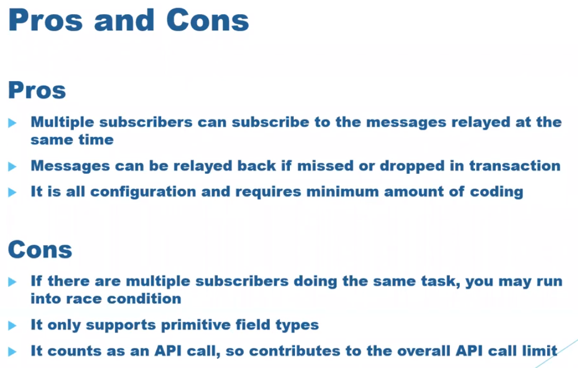

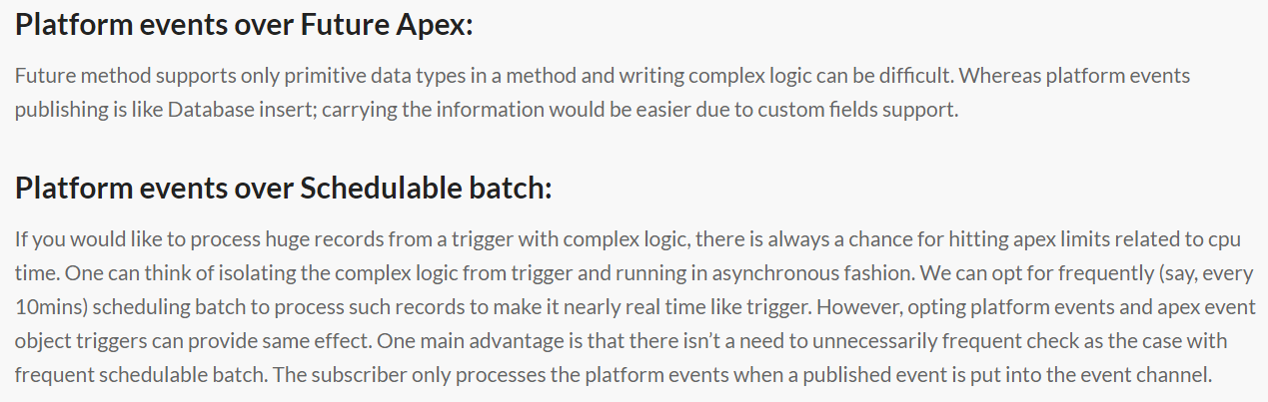

**Triggers on Opportunity/Account Contact Role objects – Using Change Data Capture**

We all know Contact Role objects have been a pain in the …! Why? Because they are not first-class objects, which implies you cannot create workflow rules, process builder or triggers on these objects.

**Use Case**

When a contact is added/updated as a Primary Contact to an Opportunity in Contact Roles related list, it should update a custom Contact Lookup field on Opportunity object with that Contact.

**Solution:**

The idea is to create a trigger on OpportunityContactRoleChangeEvent object which passes a collection of OpportunityContactRole record IDs in context, to an Apex class where we handle rest of the logic to update the Primary Contact on Opportunity.